**CASE STUDY ON JIRA**



**DONE BY:**

AISHWARYA JOHN

**TOPIC**:

Building an automation framework with the below asks   
1. Writing user stories for the given website using Jira  
2. Recording the test results with Zephyr and user stories with JIRA

**WEBSITE URL**: <http://elearningm1.upskills.in/>

**REQUIREMENT SPECIFICATIONS:**

The application http://elearningm1.upskills.in/ is built by your company,  
and the manual tester is called for testing in English language on the  
home page. The manual tester has tested and has given below write up.  
The company wants to automate the work done by manual tester, and  
generate relevant report for auditing.   
The application on the home age helps to register with the signup option  
provided, upon entering the details of mandatory fields like first name,  
lastname, e-mail, Username, pass, Confirm password, and clicking on  
Register button on same page. The message is shown on the next page of  
the username which was entered in the first page, and it is confirmed it is  
registered as on the screen a confirmation message and its validated the email which is entered. And the tester has validated to send an  
message to other user in the system with the “Compose” option in the home page.  
By clicking Compose, a new windows is opened, and tester entered

**INTRODUCTION TO JIRA SOFTWARE**

JIRA is an issue tracking tool which was developed by the software company named as Atlassian. JIRA is used for agile project management.

1. **A walkthrough for JIRA is as follows**

* Create a JIRA account by filling the required details using this website

<https://www.atlassian.com/try/cloud/signup>

* If you already have an account then click on create project under projects option.

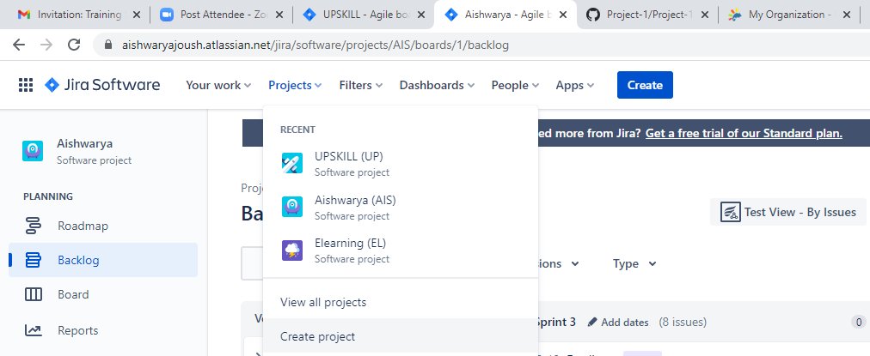

* Then click on Scrum option

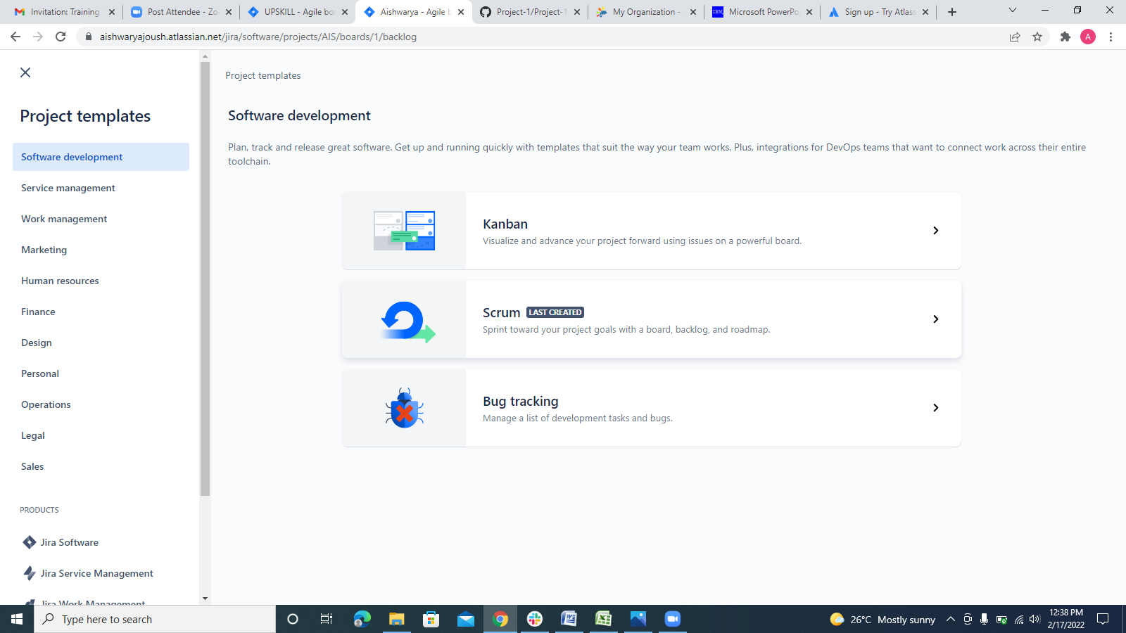

* Then click on use template option

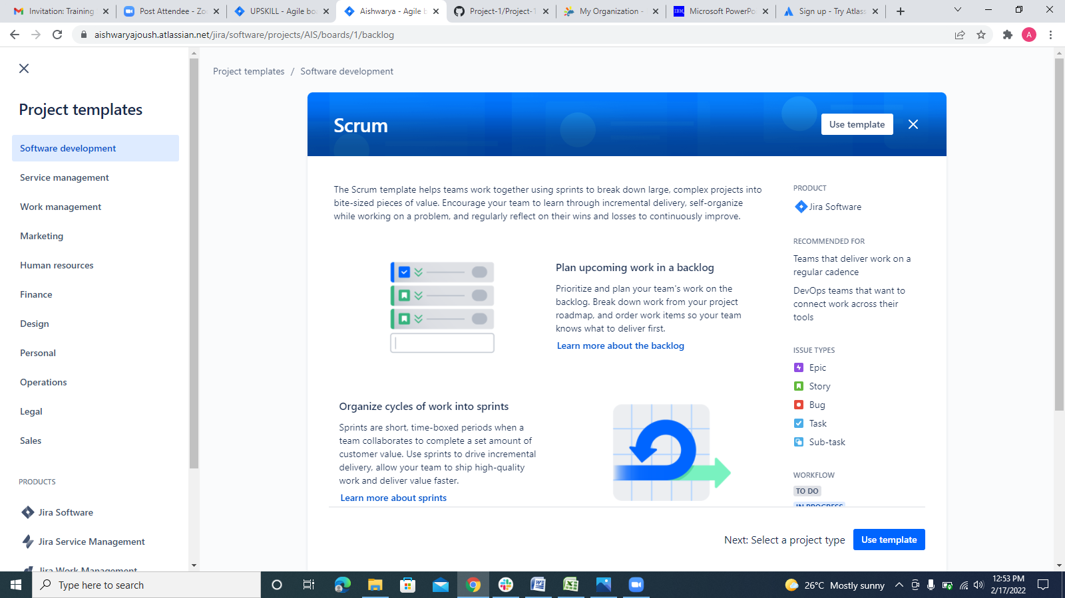

* Select the appropriate project type required.

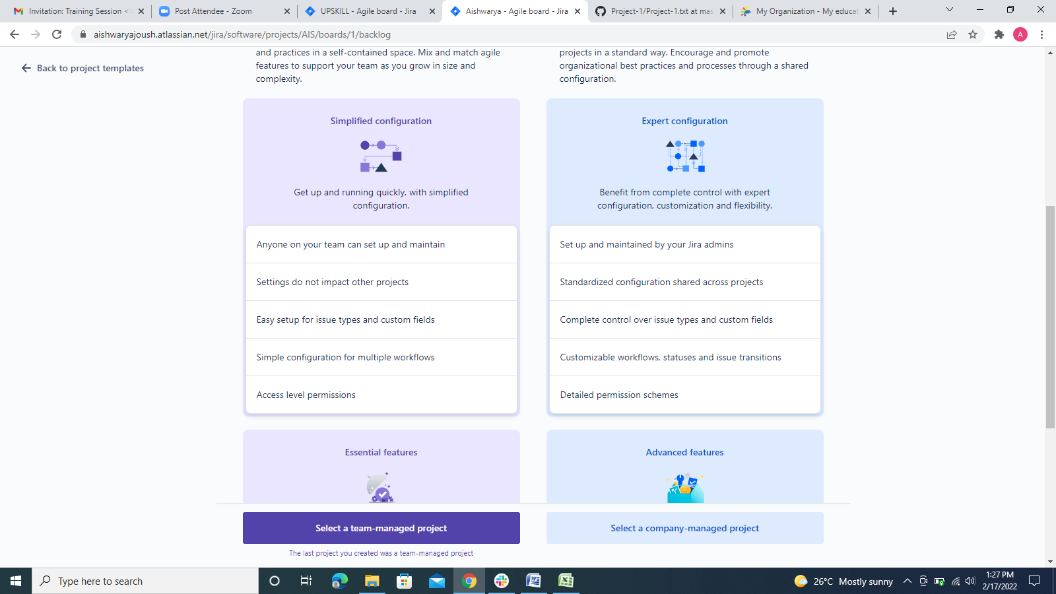

* Add your project details and click on create project option below.

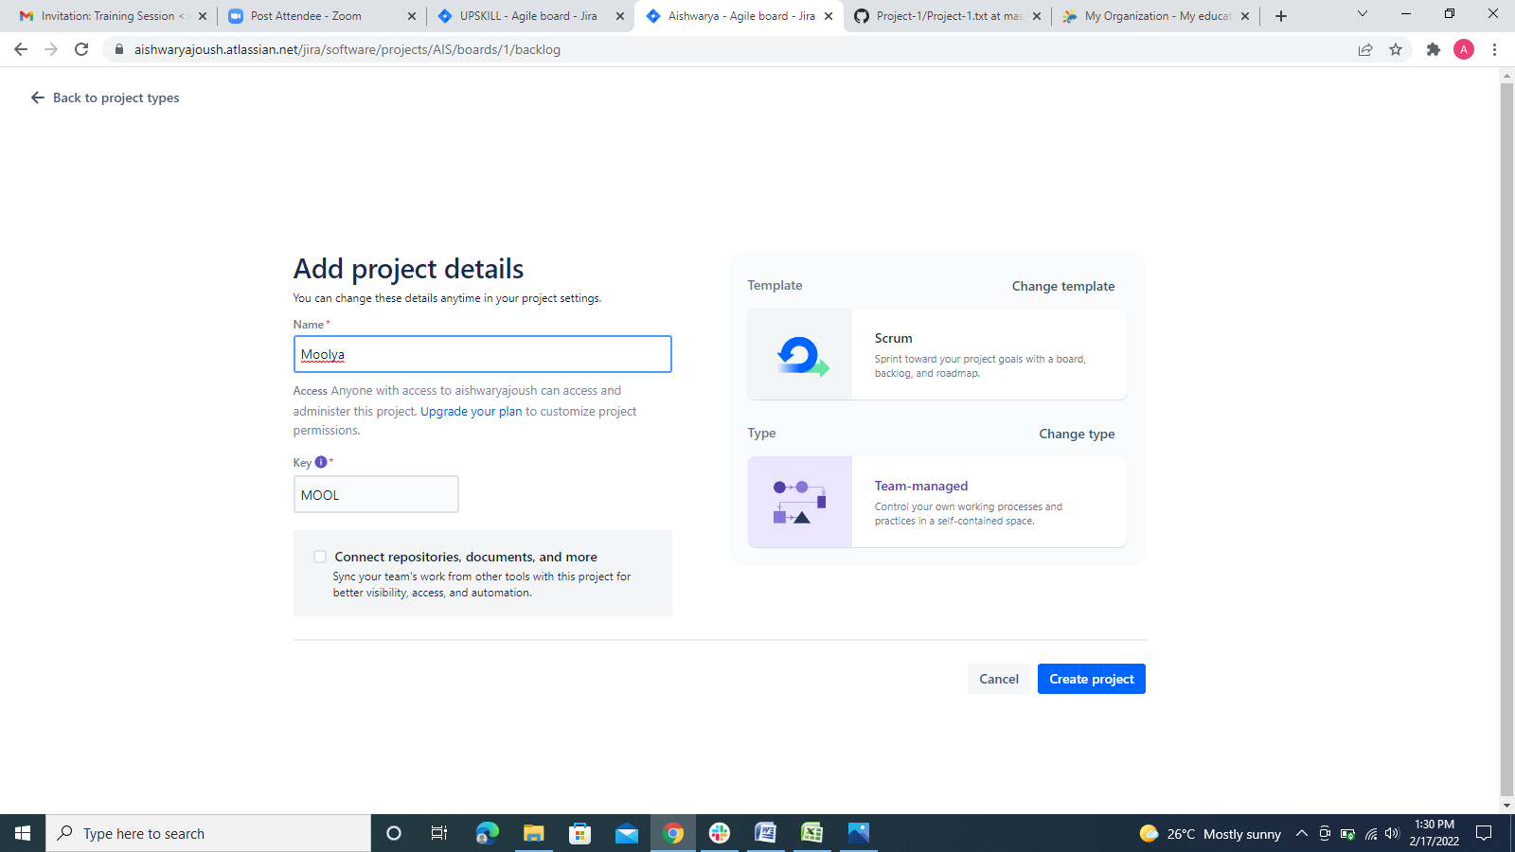

The respective project is been created in JIRA Software.

1. **Creating the agile methodology for the given website and mentioned requirements in JIRA Software.**

* Created a project named “UPSKILL” using the above mentioned steps in JIRA software.
* Enable the “Epic panel”

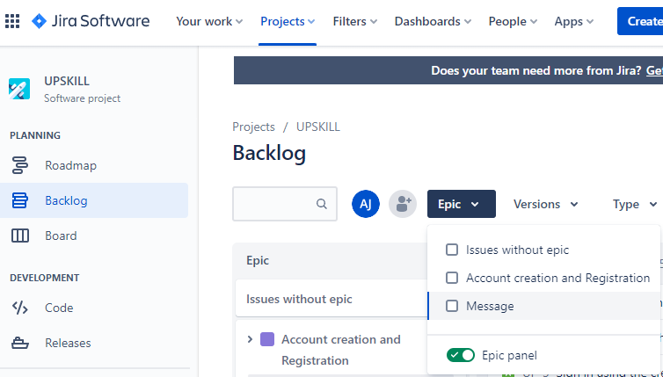

* Create the required number of epics using “create epic” option. For this project I have created 2 epics based on the requirements given.

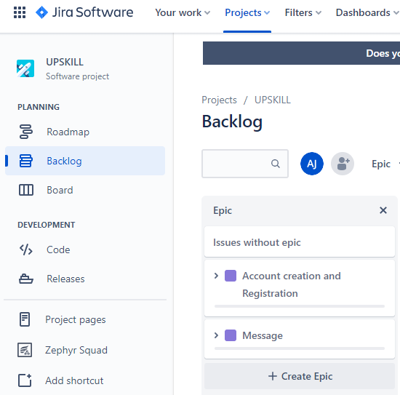

* Create user stories with respect to the website requirements given by the client for each sprint. We can create user stories by clicking on create issue option under each sprint.

Here I have created 2 sprints

1. Creating user story for the 1st sprint

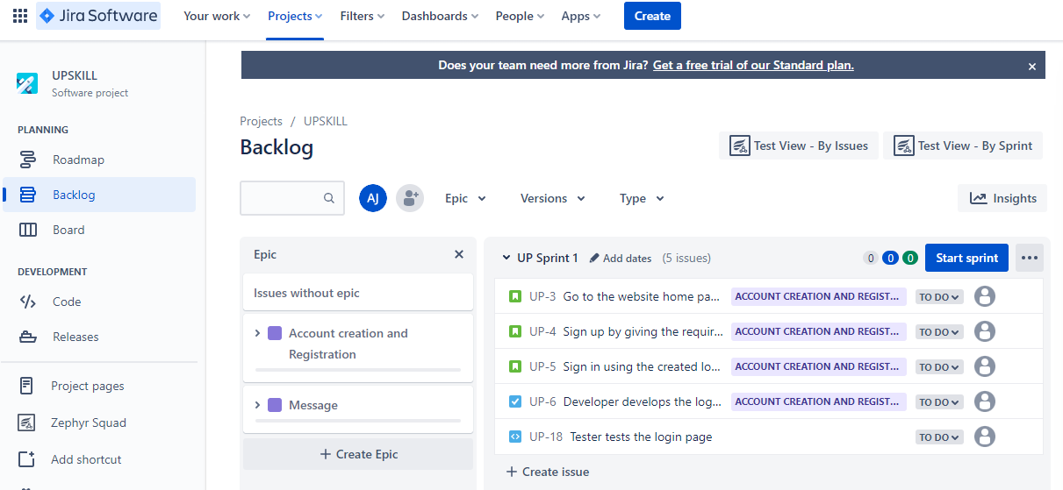

1. Creating user story for the 2nd sprint.

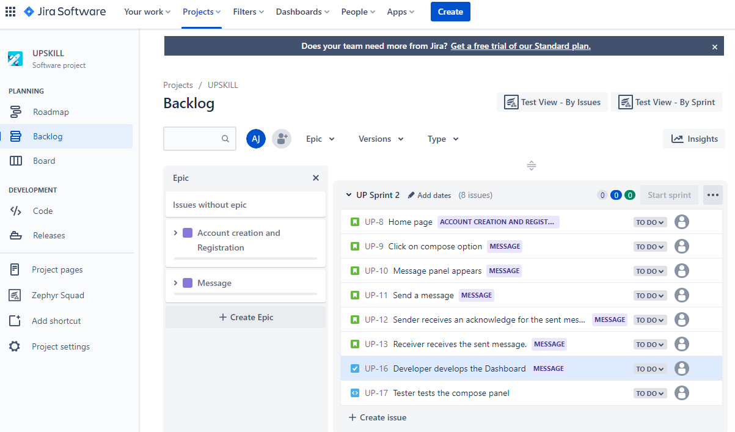

* Now, add the user stories to the respective epic. We can add the user stories to epic by dragging the particular user story and moving it to the respective epic accordingly.

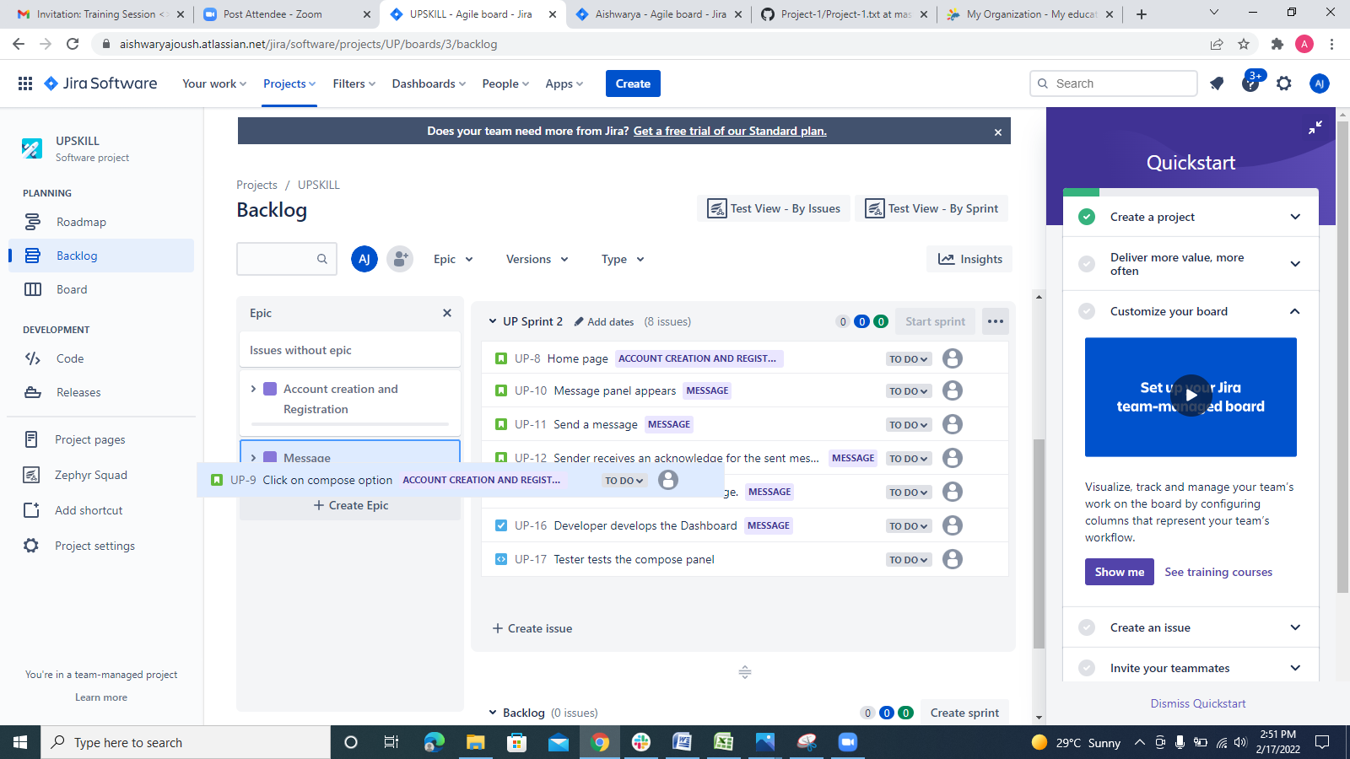

* We can view a particular epic and a particular user story with all details if required in a different browser page.

1. Click on the respective user story to view it in another page in detail.

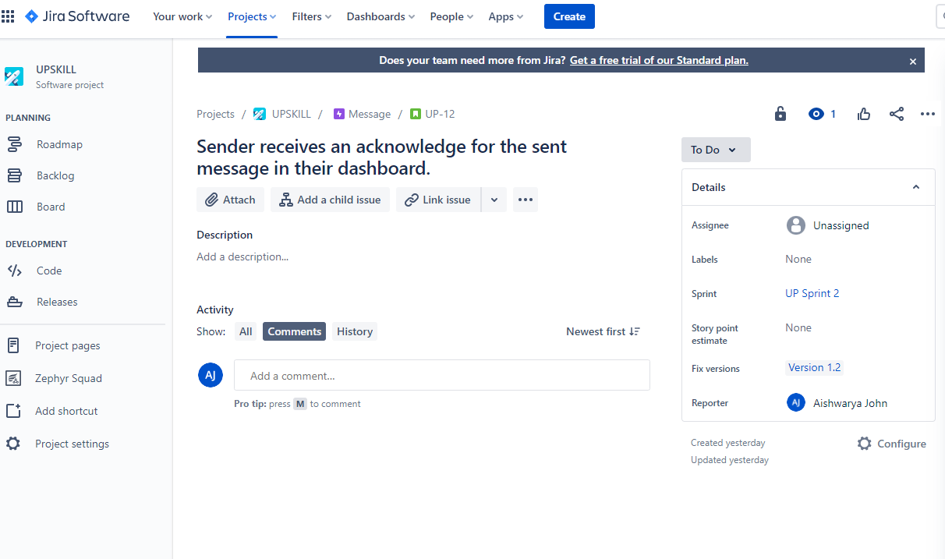

1. Click on the respective epic to view it in another page in detail.

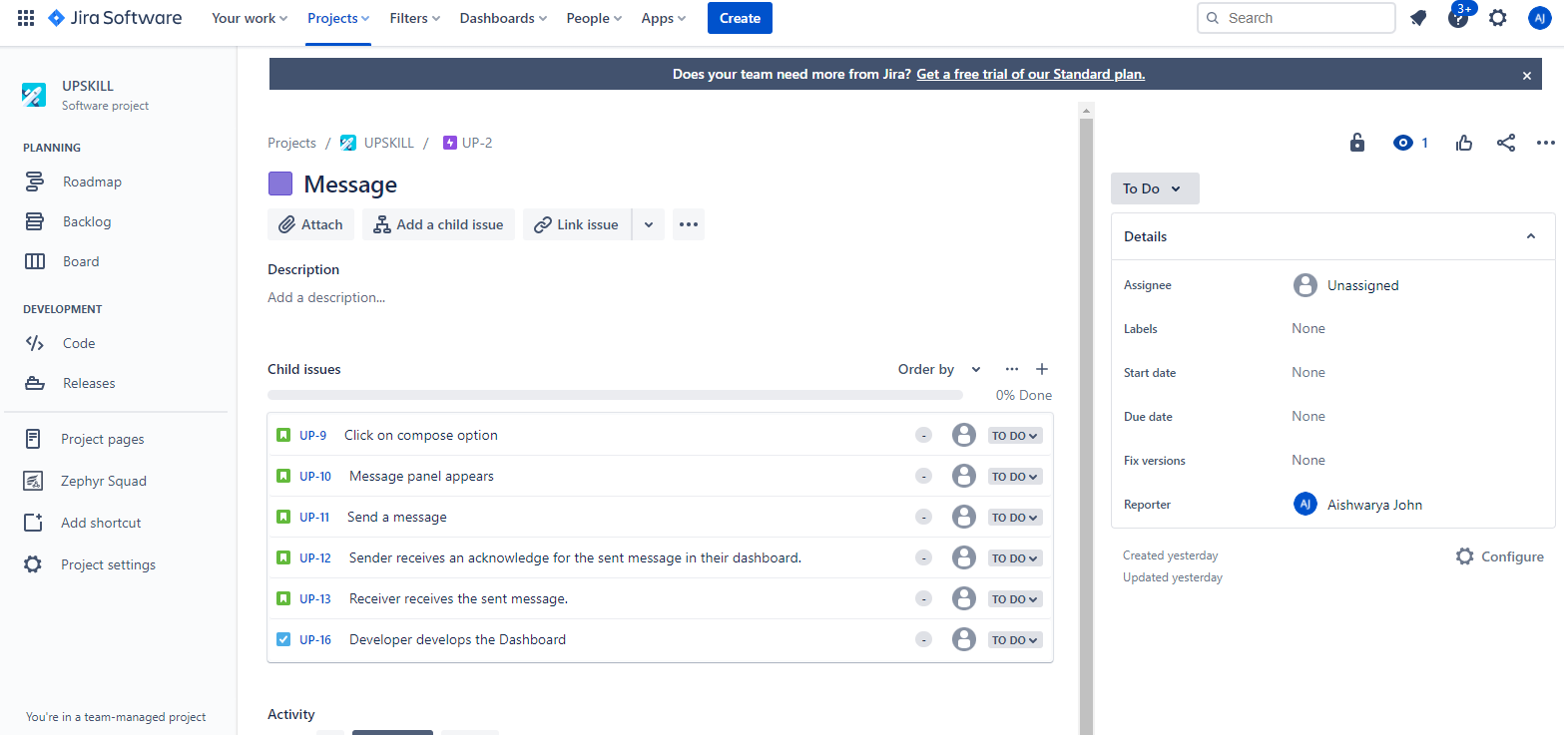

* Add the user stories/epics to the respective version. Here I have created a version 1.2 and have added all my user stories and both the epics to the same version.

1. Created a version 1.2 (unreleased)

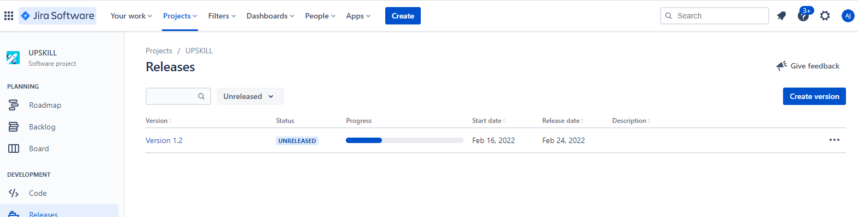

1. Selected version 1.2 under fixed version for the epic.

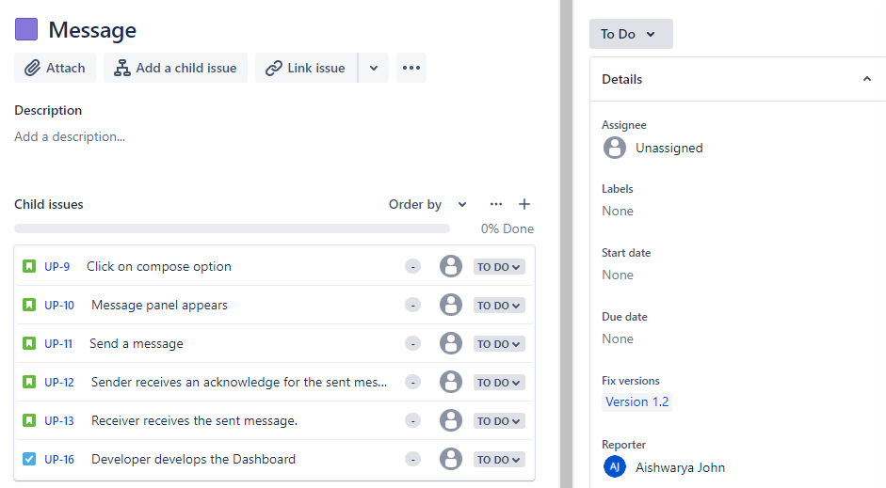

1. Selected version 1.2 for the respective user stories.

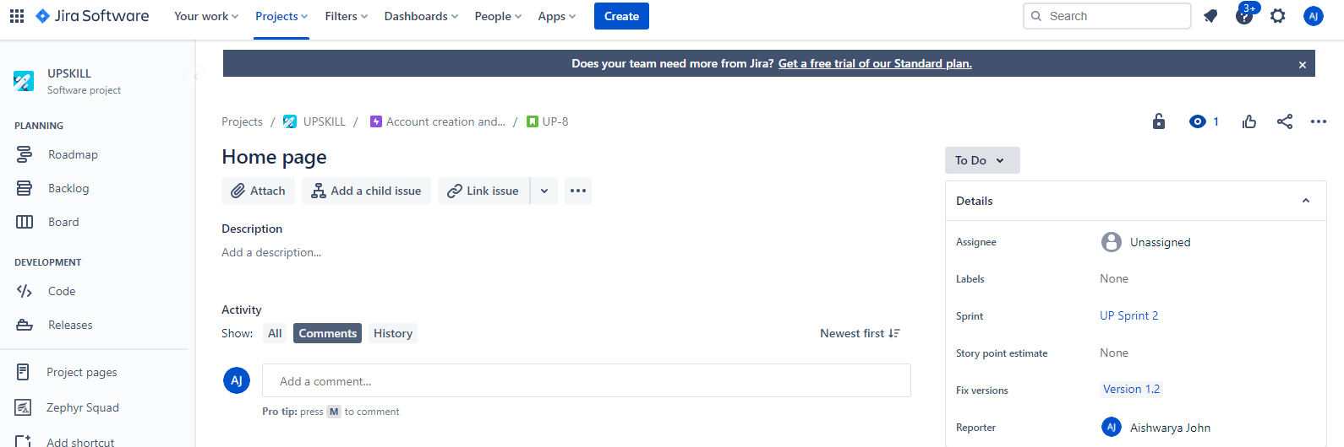

* Once we add the user stories to the respective epic then we can click on start sprint option (sprint wise) which is beside each sprint and fill the details accordingly.

.

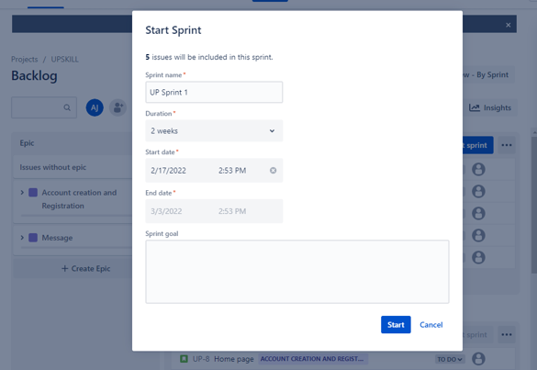

* Click on start sprint, it directs us to the board page where we can view the progress of the sprint from development to deployment and done phase using KANBANS.

For example: Once the sprint is started then the developer takes the particular user story, works on it and once the developer completes his work he pushes it to the next phase and this process continues until sprint is ready to be completed.

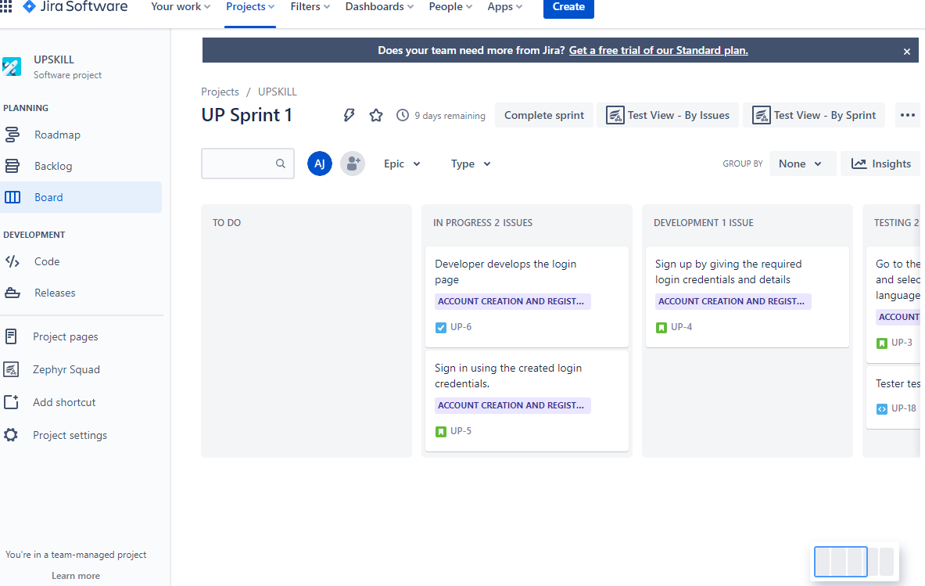

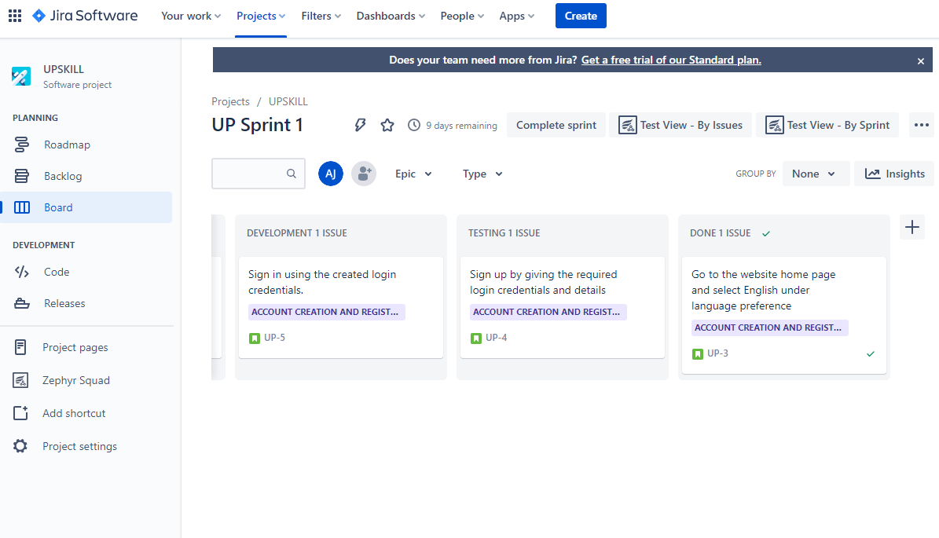

* Once all the user stories are done and are ready to be released then click on complete sprint option. The respective sprint will be completed.

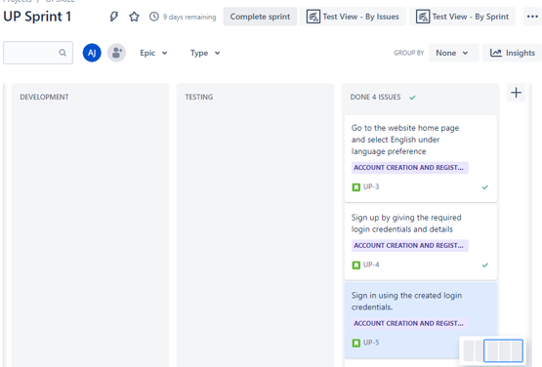

* Here I followed the same process for completing sprint 2.

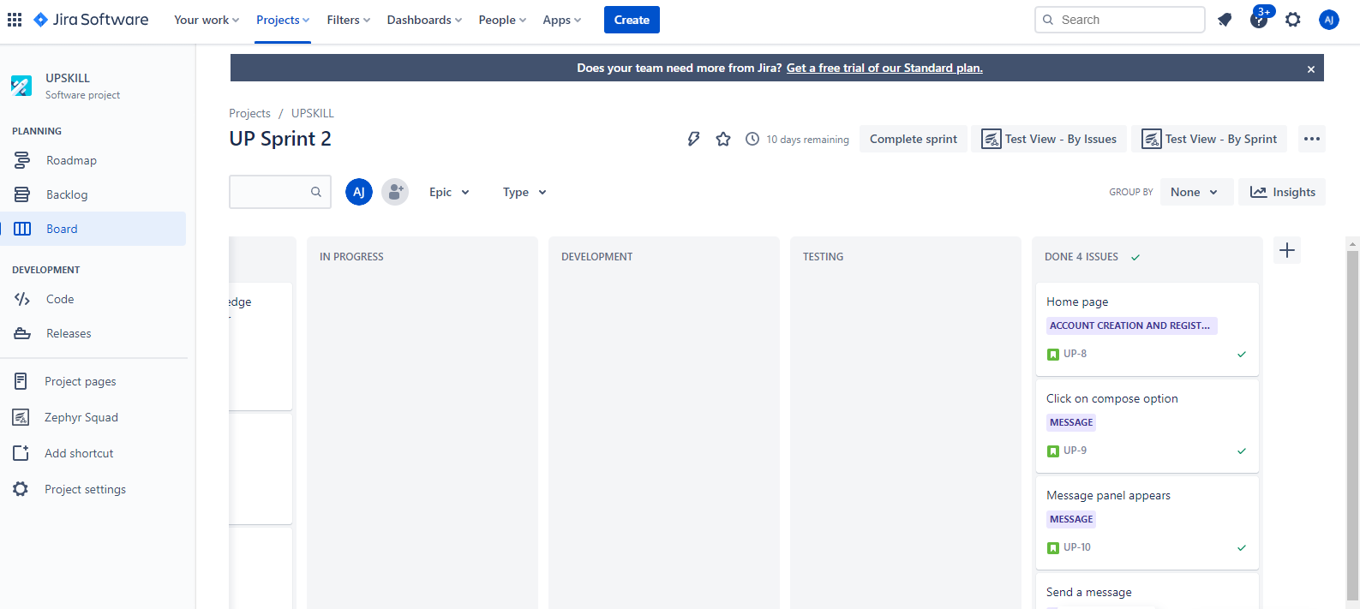

1. **Recording the test results with Zephyr squad**

JIRA has many plugins such as Bugasura, Github etc, one such plugin is known as zephyr squad.

* To enable zephyr squad we have to create an issue.
* For creating an issue type we have to click on project setting🡪 issue types🡪click on add issue types, here I have created the issue type as “Test”

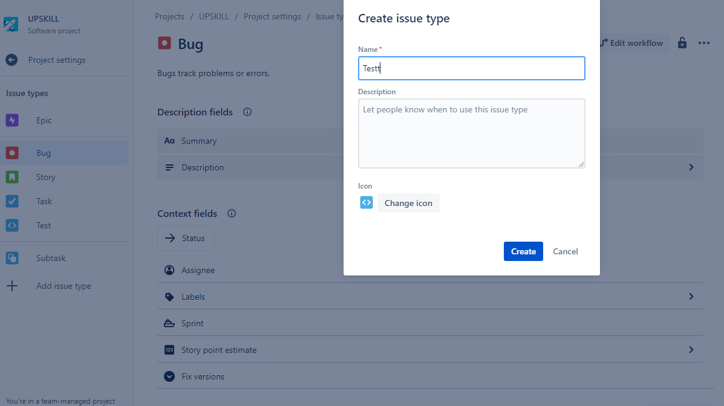

* Enable Zephyr squad by selecting the created issue type ( Test)

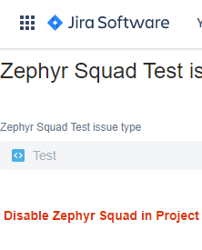

* Click on zephyr🡪 Cycle summary 🡪 Create new test cycles and give the required details.

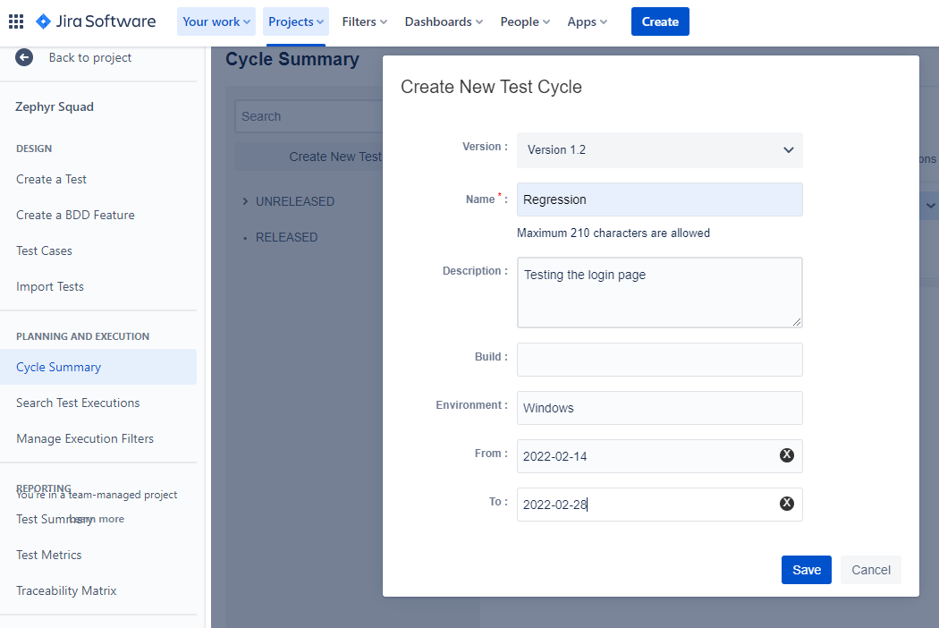

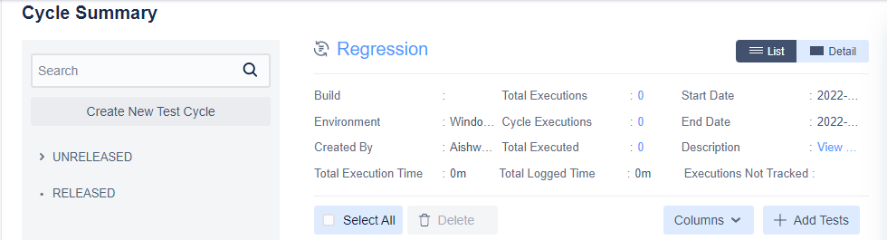

* Here I have created test issue type in which the tester tests the login page and compose panel ( according to the requirements mentioned)
* Now click on the test issue which is created and then click on add to test cycle option. Fill the required details accordingly and click on add.

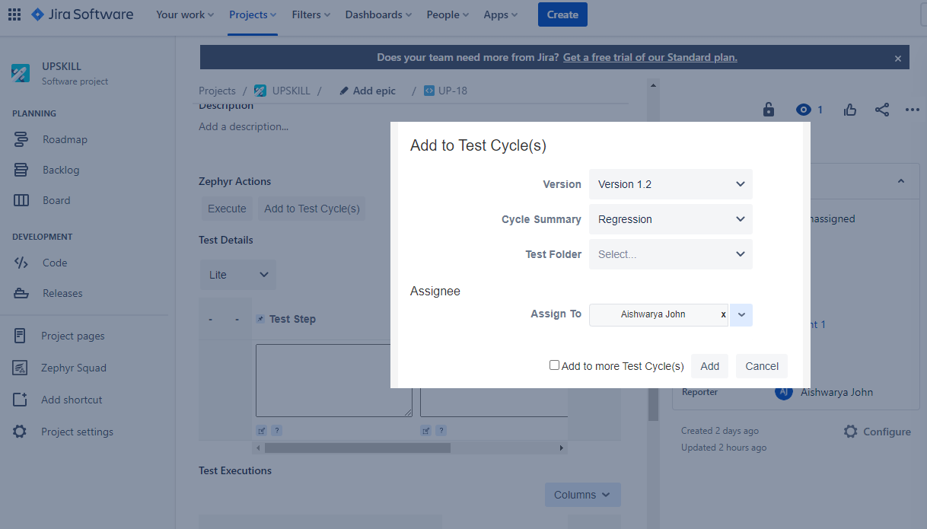

* Test cycles

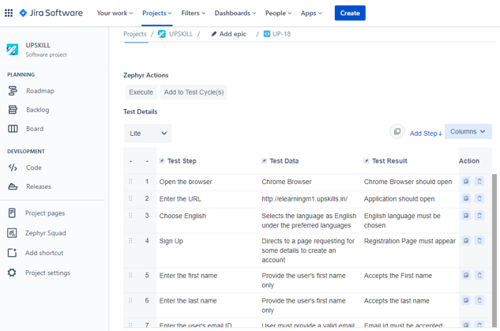

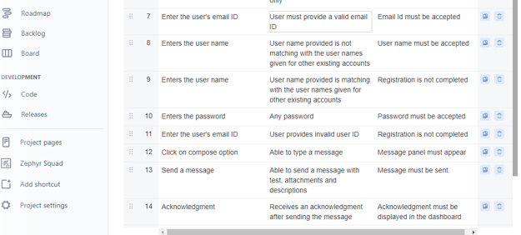

* Click on execute option to execute the given test cycle.

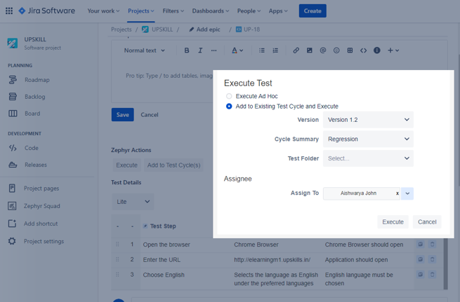

1. **Check whether all your test details are working well with respect to the given website and the given test result is been achieved for all the test steps accordingly.**
2. Chrome browser opens when click.

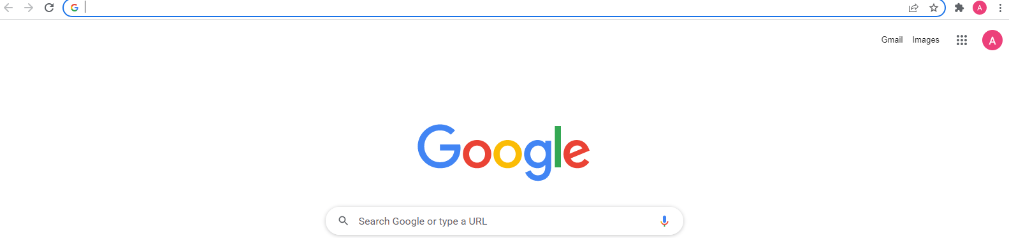

1. Application opens when we enter the website URL in the browser and English language can be chosen under language preference.

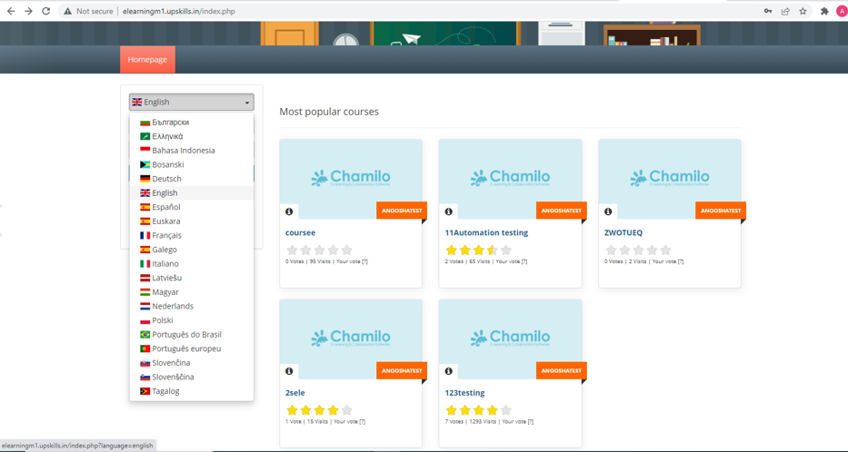

1. Sign up by giving the first name, last name, unique user name, password, valid email ID (mandatory details) and other details if required and click on register 🡪 Registration successful and account is created

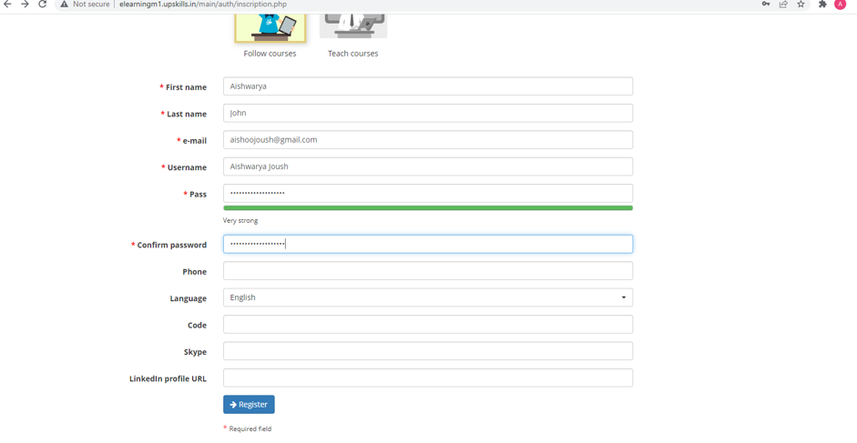

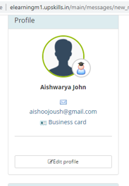

1. Click on compose option from the dashboard 🡪 Message panel appeared 🡪 Sends a message (if needed we can attach a file and description along with the message) 🡪 Message sent successfully.

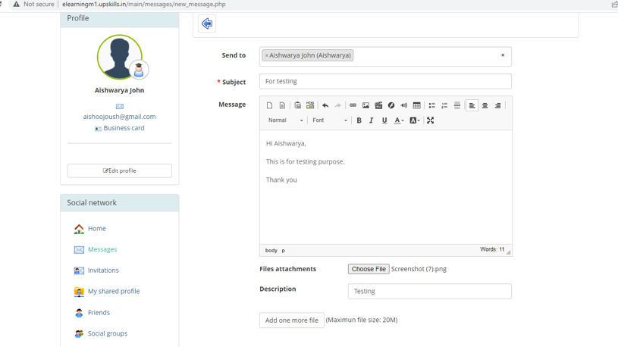

1. Message which was sent is been received by the receiver.

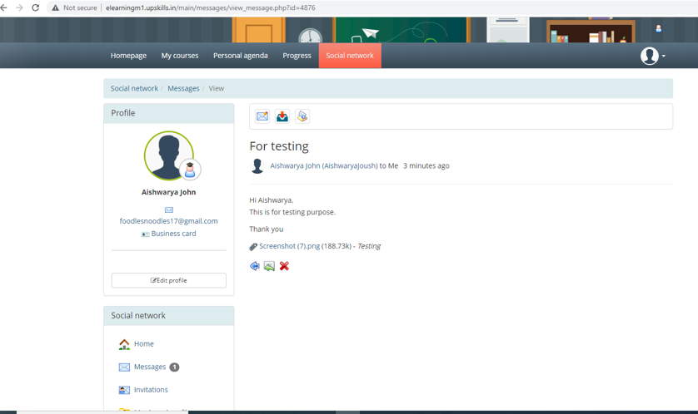

1. Received an acknowledgment in our (sender’s) dashboard once we send a message.

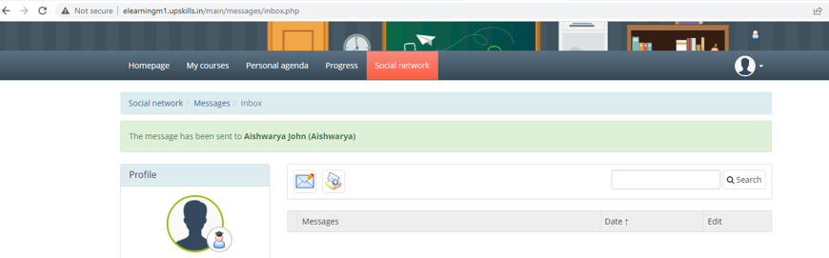

* The given test results are been achieved for all the test steps. Therefore the execution is done and the product is ready to be released by passing all the requirements given.

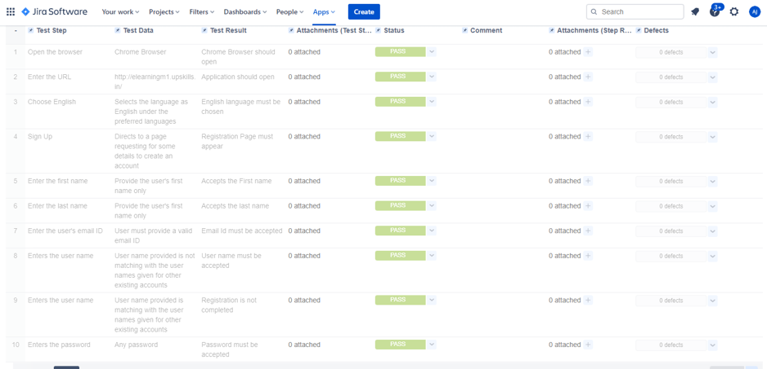

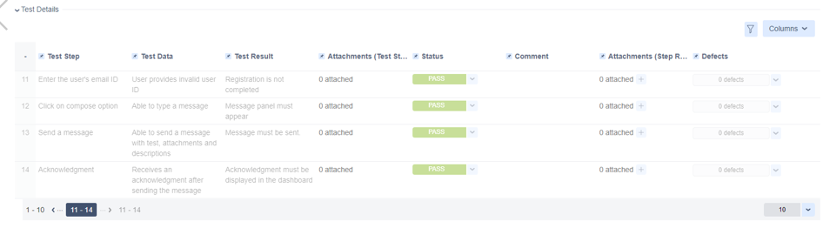

* Click on Done option 🡪 Executed(Pass)

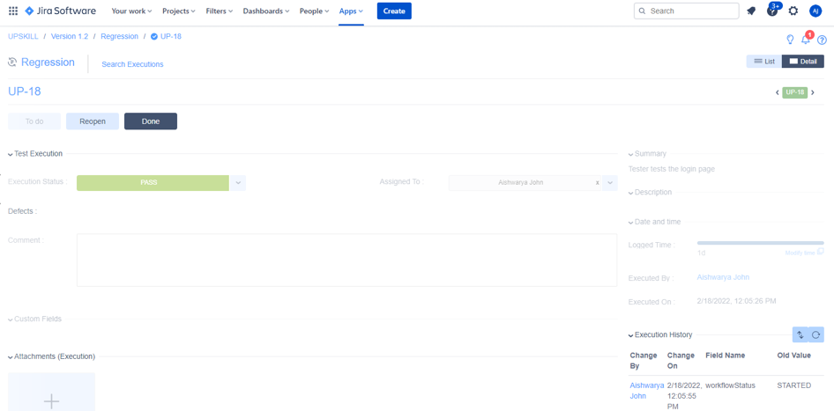

* Cycle summary for this project

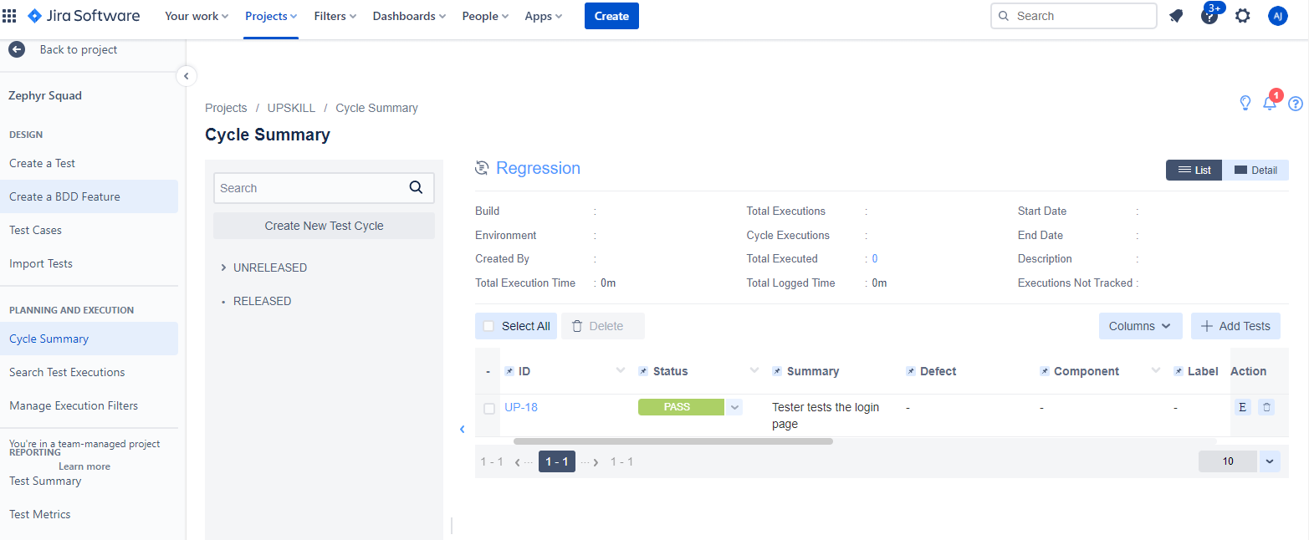

* Test execution for this project

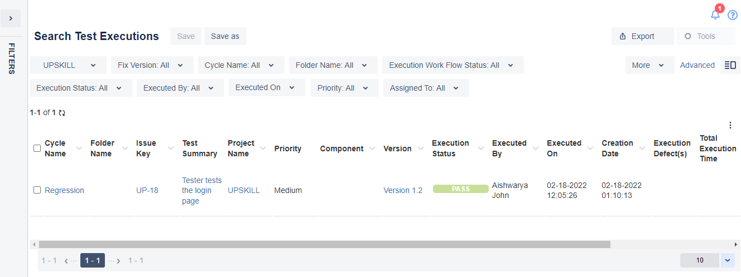

* Test matrix for this project

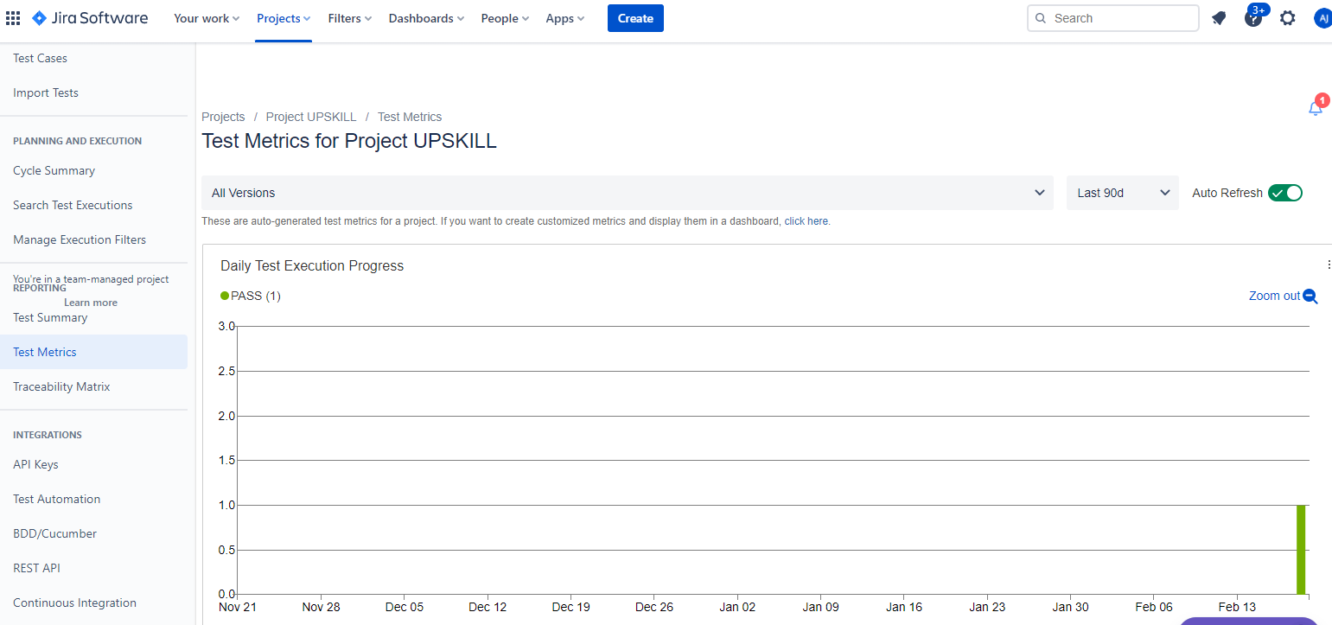

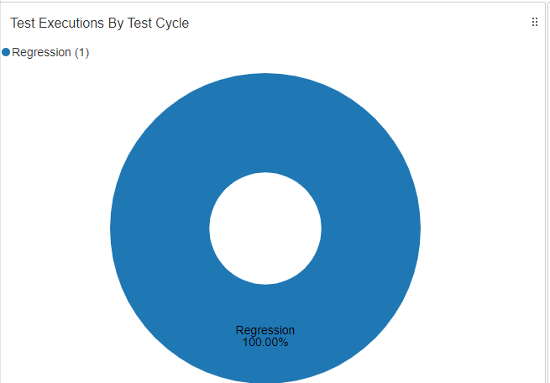

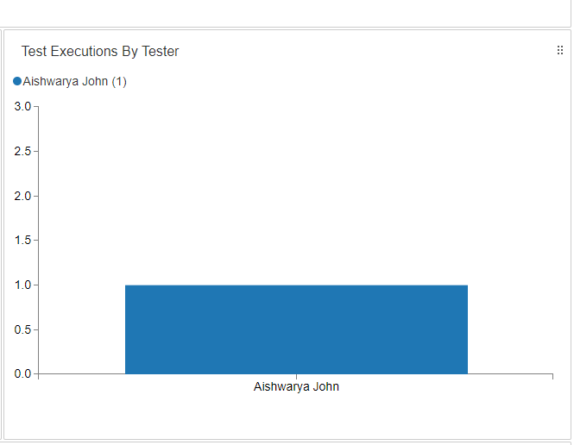

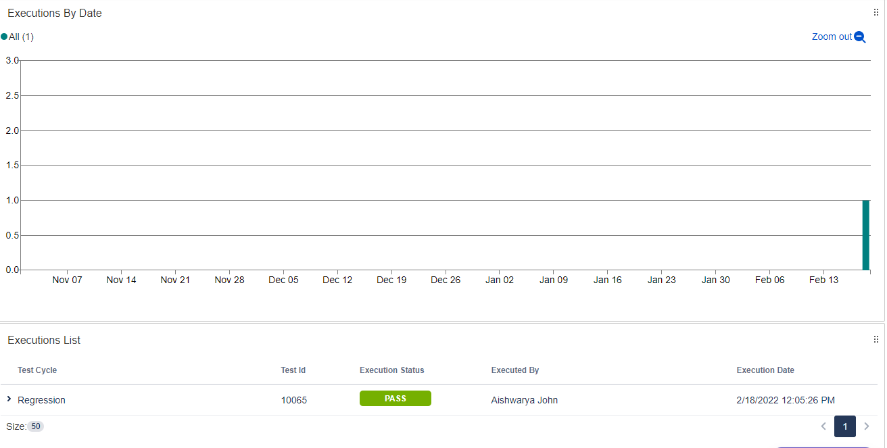

* Test summary for this project.

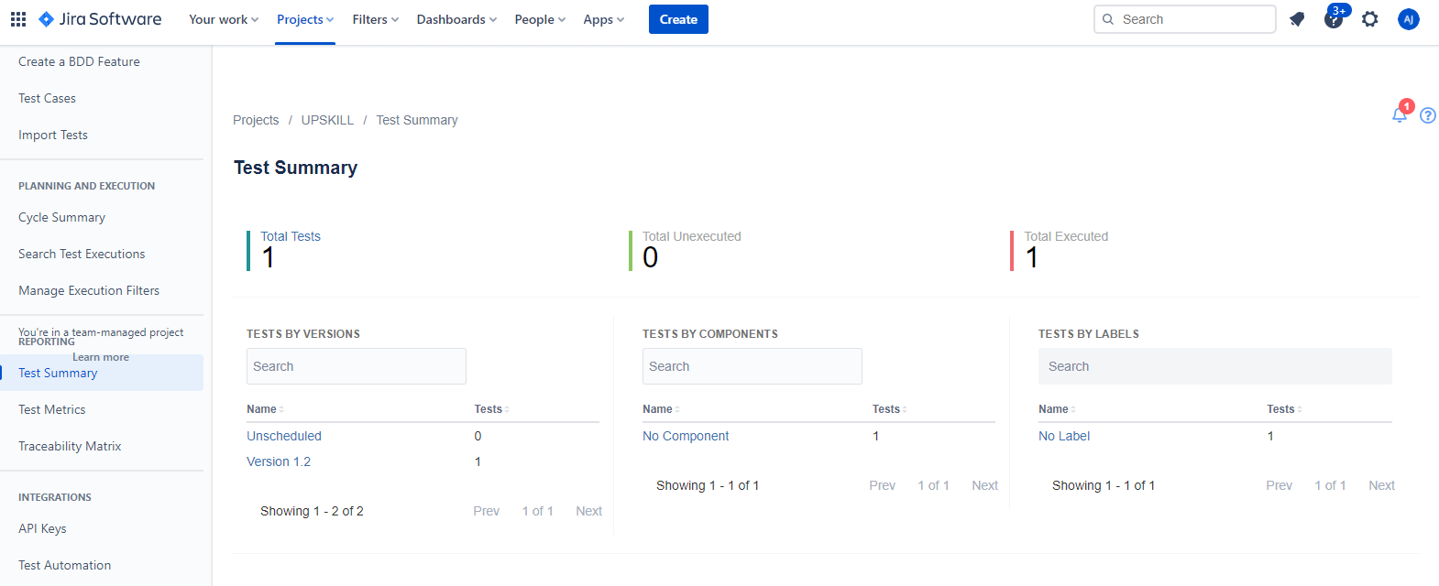

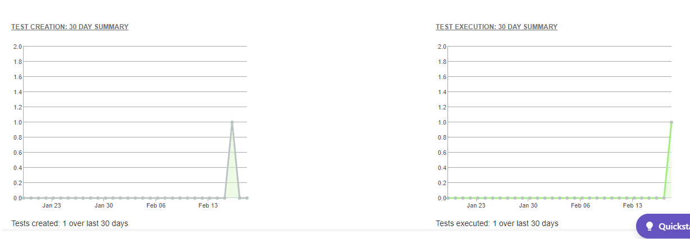

* Traceability Matrix

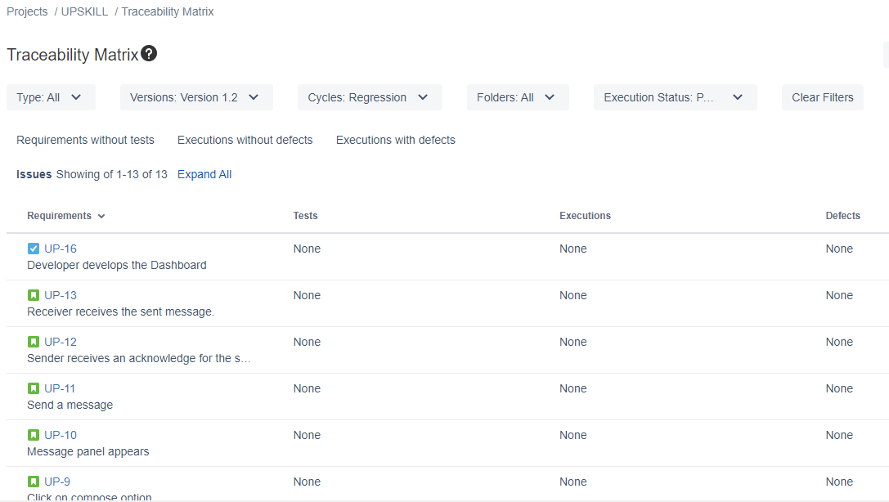

* Traceability Matrix in Excel report

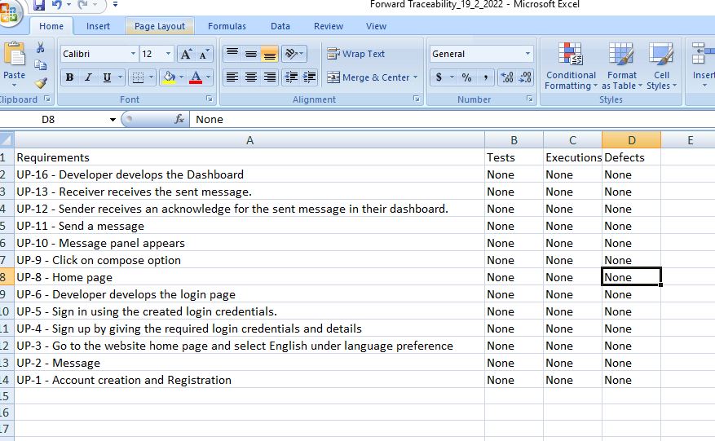

* Test cases for this project.

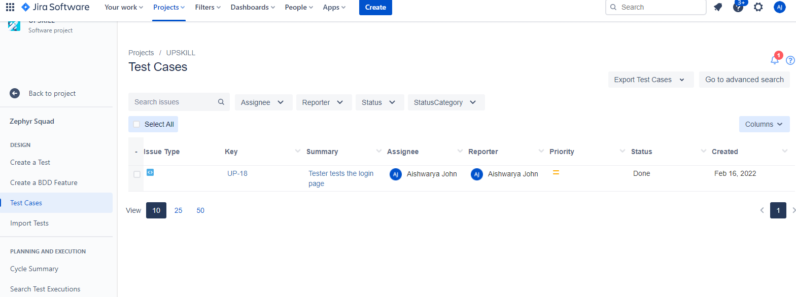

* Excel report for the same test cases.

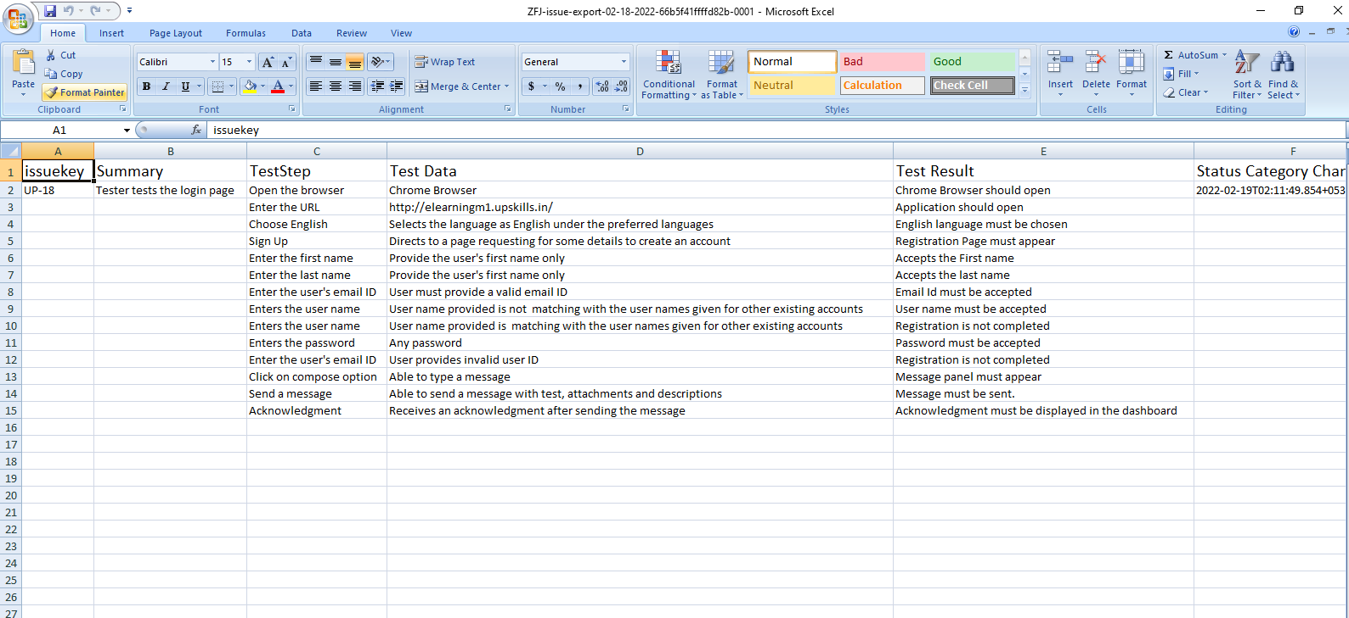

I have attached the excel report of both the traceability matrix and test case along with the word document.